# **How to repair or rebuild the WMI Repository on Windows 10**

Sometimes **WMI Repository** gets corrupted which results in Provider Load Failure below is the sample.

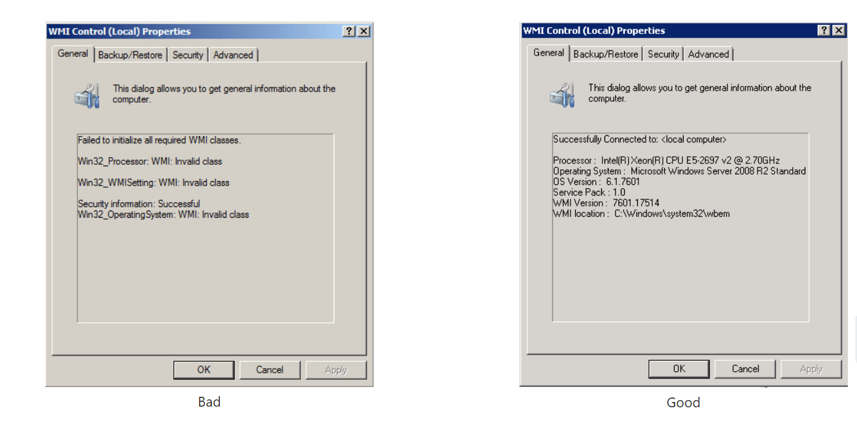

Below are the steps how to**repair or rebuild the WMI Repository** on Windows 10.

Step -1 🡪 Launch the WMI MMC snapin by **Start** -> **Run** -> then enter **WMIMGMT.MSC**

Right click **WMI Control (Local)** and click **Properties check the status of the WMI status whether it’s reporting as connected to the local computer or not. If, not below are the errors that you might get some sample are given below.**



**Below is a list of errors and permission issues you might see-**

1. Unable to connect to root default or rootcimv2 namespaces. It fails with the error code “0x80041002” pointing to “WBEM_E_NOT_FOUND.”
2. When you open Computer Management and Right Click on Computer Management (Local) and select Properties, you get the following error: “**WMI**: Not Found” or it hangs trying to connect
3. 0x80041010
4. WBEM_E_INVALID_CLASS
5. Trying to use *wbemtest*, and it hangs
6. Schemas/Objects missing
7. Strange connection/operation errors (0x8007054e).

Step -2 🡪 Now you need to open a CMD in an [elevated Command Prompt](https://www.thewindowsclub.com/how-to-run-command-prompt-as-an-administrator) (Run as Admin).

Run Command 🡪 winmgmt /verifyrepository

If the repository has an issue, it will respond “repository is not consistent,” if not then its something else causing the issue. Now that you are sure the corruption exists let’s follow these tips to repair or rebuild the WMI repository.

### Step -3 🡪 Reset WMI Repository

* Run the command: winmgmt /salvagerepository

Then execute the command to see if it now comes back as consistent-

* Run the command: winmgmt /verifyrepository

Then execute the command to see if it now comes back as consistent-

* Run the command: winmgmt /resetrepository

It will help you fix the WMI repository. Here is what each of the [WMI commands](https://www.thewindowsclub.com/wmi-commands-on-windows-7) mean:

* **salvagerepository:**This option when used with winmmgmt command performs a consistency check. If an inconsistency is detected, it rebuilds the repository.
* **verifyrepository:**Performs a consistency check on the WMI repository.
* **resetrepository:**The repository is reset to the initial state when the operating system is first installed

### Step -4 🡪 Force Recover WMI

WMI comes with an inbuilt self-recovery process. When the WMI service restarts or detects any corruption, the self-recovery procedure will trigger automatically. It happens in two ways:

**AutoRestore**: Here it will use the backup images if the[VSS (Volume Shadow copy) backup](https://www.thewindowsclub.com/vss-volume-shadow-copy-service) is turned on.

**AutoRecovery**: In this, the rebuilding process will generate fresh images of Repository based on registered MOFs. The MOFS is available in the registry here:

HKLM\Software\Microsoft\WBEM\CIMOM: Autorecover MOFs

**Note:** Autorecover MOFs is a key. Double-click on it to check the value.

### WMI Self-recovery does not work

If the self-recovery doesn’t work, you can always use the force-recovery process.

Check regkey value is **empty**or not**here:**

HKLM\Software\Microsoft\WBEM\CIMOM\Autorecover MOFs

If the above regkey is empty, copy-paste the regkey value from another machine. Make sure it’s from System which is equivalent to the computer in question.

Next, execute the command-

Winmgmt /resetrepository

If you get an error “WMI repository reset failed. Error code:0x8007041B. Facility: Win32”, then stop all [Dependency Services](https://www.thewindowsclub.com/find-dependencies-windows-service) on the WMI service by running the following commands:

net stop winmgmt /y

Winmgmt /resetrepository

After performing the above mentioned steps WMI service issue will get fixed if still doesn’t fix than we need to re-format the machine.